ICSI-418 Software Engineering Spring 2019

Semester Project Due May 2, 2019

**Overview**

The semester project for ICSI-418 consists of a base level of required functionality that can be implemented using one of several development platforms. There is one platform that is required for implementation that one team will be responsible for. More on the platforms below. This project will be the final for the course and must be complete by the date indicated above.

**Required Functionality**

1. The required functionality consists of a web based testing tool that can be used to manage and administer tests. The end user functionality is similar to the Blackboard quiz functionality you have experienced in this class
2. For this implementation there are only two question types needed to be supported, multiple choice and true/false. All users of the system should be required to login with a userid and password.
3. The application needs to be able to allow an administrative user to create a test question and supply the corresponding answers.
4. Administrative users should be able to: create user ids (both admins and test users), create, edit and delete questions and answers for the test bank, categorize questions for easy accessibility, create a test by selecting questions from the test bank and run reports that are sent to the screen. Questions can contain text and images.
5. A user (admin) should be able to select a test from the test bank and take the test. The test should save results as the user progresses but not commit the test until submitted. The user should be able to get feedback on the test results after submitting the test for scoring.
6. The user should be able to see a listing of the tests they have taken and a hyperlink to the results of the test with the questions and answers.
7. The admin user should be able to see a listing of all the tests users have taken and a hyperlink to the results of the test with the questions and answers.
8. The admin user should be able to see a listing of all the tests in the test bank and a hyperlink to the test with the questions and answers.
9. The system should be able to have a customizable header and footer on the page so that an image and text can be customized for each Admin user. For now use the UAlbany logo and text.
10. The system should be able to import from a file, a test with questions and answers that is to be loaded into the test bank.

**Platforms**

There are many choices of platforms that the application can be implemented on. Below is a sample of three. However, the preference is that 1 team implement the application on Platform Choice 1.

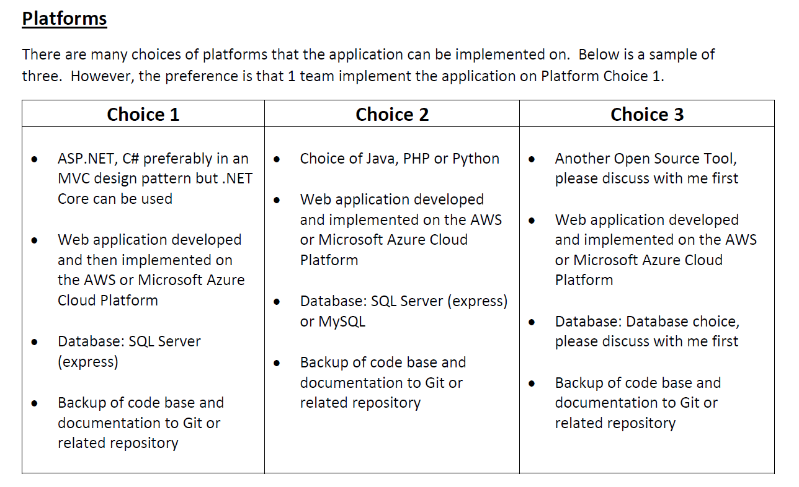

**Deliverables**

The deliverables for this project are as follows:

• Requirements documentation ✓

• Appropriate level of design documentation ✓

• Product Backlog ✓

• Project Plan with Sprints laid out ✓

• Code Repository ✓

• Testing Plan and Results ✓

• Deployment Plan Including Install Scripts (if applicable) ✓

• Maintenance Plan ✓

**Project Presentation**

The project presentation, which will be due on April 25th, is a wrap-up of the project. Required elements are:

1. A statement of the project,----------Jake
2. the design you used, ----------Gil
3. the technology stack you used,-----------Kaz
4. your sprint plans, -----------Geo
5. what went well, ----------Zae
6. what you would have done differently----------Vic
7. lessons learned from the project. ----------Dylan

All team members should contribute on the presentation. Use PowerPoint, slides or some other similar presentation tool.

**Grading**

Working application – 30%

Deliverables – 50%

Project Presentation Last Day of Classes – 20%